**Shashwat Tripathi**

**D10A 58**

**BATCH: C**

**LAB EXPERIMENT NO: 3**

**INPUT-**

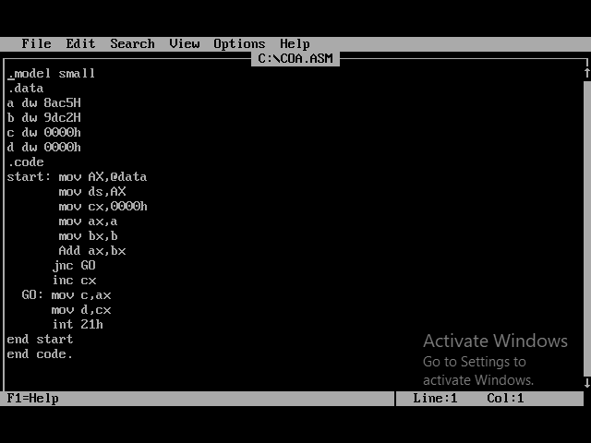

**OUTPUT-**

